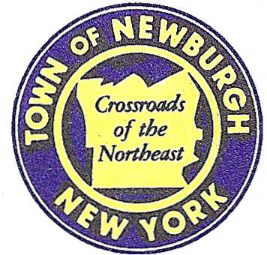

TOWN OF NEWBURGH
_______Crossroads of the Northeast __________________________

21 HUDSON VALLEY PROFESSIONAL PLAZA
NEWBURGH, NEW YORK 12550

PLANNING BOARD
JOHN P. EWASUTYN, CHAIRMAN
TELEPHONE 845-564-7804
FAX 845-564-7802
E-MAIL: planningboard@townofnewburgh.org

PLANNING BOARD AGENDA

November 5th, 2020
7:00 PM

*PLEASE NOTE: The Planning Board Meeting will start at 7:00 P.M. and all Applicants/Representatives
are to be present at that time. The Meeting will be held in the Meeting Room of Town Hall,
located at 1496 Route 300, Newburgh NY.*

Online meeting materials: http://www.townofnewburgh.org/cn/meetings/

- Patton Ridge (12-18)
Patton Road & Route 52 REQUEST FOR EXTENSION UPDATE
Section 47, Block 1, Lot 44
Zone: R-2
Rep: Kirk Rother, P.E.
5 St. Steven’s Lane
Warwick, New York 10990

- Amer & Duch Lot Line Change (20-13) INITIAL APPEARANCE
Kathleen Heights & Frozen Ridge Road LOT LINE CHANGE
Section 20, Block 1, Lot 134.2,14.13
Zone: R-2
Rep: Automated Construction Enhanced Solutions, Inc./Jonathan N. Millen
1229 Route 300, Suite 4
Newburgh, NY 12550

- NPA Site Plan (17-03)
NYS Route 747 Blvd. COMMERCIAL SITE PLAN
Section 89, Block 1, Lot 80.2 & 80.1
Zone: IB
Rep: Zen Design Consultant, Inc.
6 Old North Plank Road
Newburgh, NY 12550

- Polo Club (18-12) RECEIPT OF FSEIS
Route 300 & Jeanne Drive
Section 39, Block 1, Lot 1 & 2.12
Zone: R-3
Rep: Engineering & Surveying Properties, P.C.
71 Clinton St.
Montgomery, NY 12549

- Darrigo Solar (19-24)
86 Lakeside Road SOLAR FARM
Section 86, Block 1, Lot 96 SPECIAL USE
Zone: R-1
Rep: Jeffrey Lease
597 Grand Ave.
Newburgh, NY 12550

PLANNING BOARD BUSINESS-November 5th, 2020
WORK SESSION—5:30 PM Start time

